Debounce

Pushbuttons often generate spurious open/close transitions when pressed, due to mechanical and physical issues: these transitions may be read as multiple presses in a very short time fooling the program. This example demonstrates how to debounce an input, which means checking twice in a short period of time to make sure the pushbutton is definitely pressed. Without debouncing, pressing the button once may cause unpredictable results. This sketch uses the millis() function to keep track of the time passed since the button was pressed.

Hardware Required

* Arduino or Genuino Board
* momentary button or switch
* 10k ohm resistor
* hook-up wires
* breadboard

Circuit

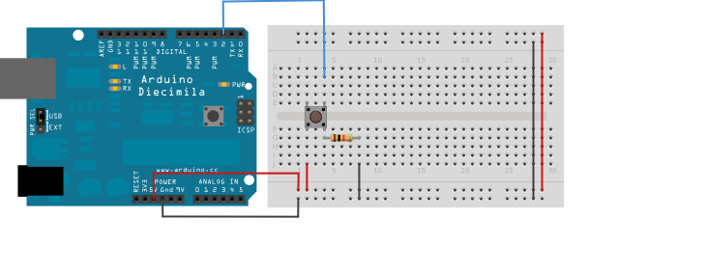

Schematic

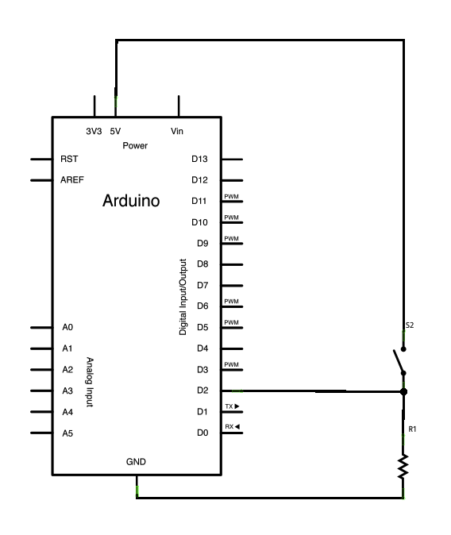

Code

*// constants won't change. They're used here to set pin numbers:*  
const int buttonPin = 2;    *// the number of the pushbutton pin*  
const int ledPin = 13;      *// the number of the LED pin*  
  
*// Variables will change:*  
int ledState = HIGH;         *// the current state of the output pin*  
int buttonState;             *// the current reading from the input pin*  
int lastButtonState = LOW;   *// the previous reading from the input pin*  
  
*// the following variables are unsigned longs because the time, measured in*  
*// milliseconds, will quickly become a bigger number than can be stored in an int.*  
unsigned long lastDebounceTime = 0;  *// the last time the output pin was toggled*  
unsigned long debounceDelay = 50;    *// the debounce time; increase if the output flickers*  
  
void **setup**() {  
  pinMode(buttonPin, INPUT);  
  pinMode(ledPin, OUTPUT);  
  
  *// set initial LED state*  
  digitalWrite(ledPin, ledState);  
}  
  
void **loop**() {  
  *// read the state of the switch into a local variable:*  
  int reading = digitalRead(buttonPin);  
  
  *// check to see if you just pressed the button*  
  *// (i.e. the input went from LOW to HIGH), and you've waited long enough*  
  *// since the last press to ignore any noise:*  
  
  *// If the switch changed, due to noise or pressing:*  
  if (reading != lastButtonState) {  
    *// reset the debouncing timer*  
    lastDebounceTime = millis();  
  }  
  
  if ((millis() - lastDebounceTime) > debounceDelay) {  
    *// whatever the reading is at, it's been there for longer than the debounce*  
    *// delay, so take it as the actual current state:*

*// if the button state has changed:*  
    if (reading != buttonState) {  
      buttonState = reading;  
  
      *// only toggle the LED if the new button state is HIGH*  
      if (buttonState == HIGH) {  
        ledState = !ledState;  
      }  
    }  
  }  
  
  *// set the LED:*  
  digitalWrite(ledPin, ledState);  
  
  *// save the reading. Next time through the loop, it'll be the lastButtonState:*  
  lastButtonState = reading;  
}